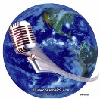
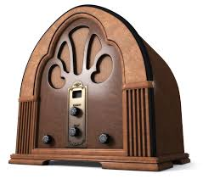
Silver Comet Amateur Radio Society

7th Annual Broadcast Band DX Contest
The SCARS 7th Annual AM Broadcast Band DX Contest starts
0001-UTC on 01 October 2021 and ends 2359-UTC on 31 October 2021.

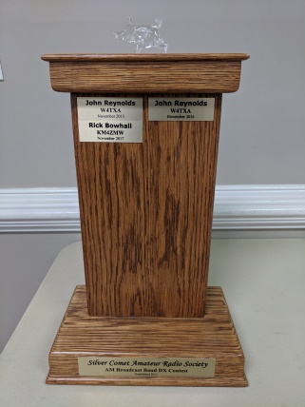
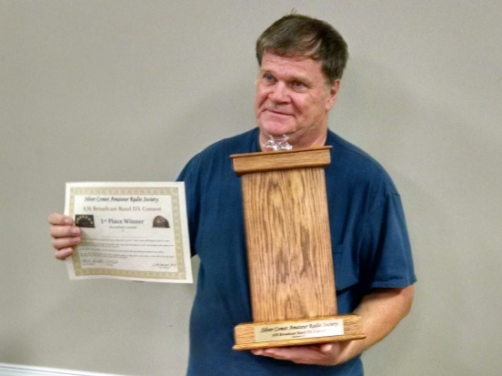This unique contest is a local “just for fun” club contest that lasts for a whole month. That gives everyone a chance to participate. Prizes such as a paper certificate, used batteries, worn out tubes and a nice custom made, one of a kind trophy (on loan) are awarded.
2018 Winner
W4TXA – John Reynolds

DXing the AM Radio Broadcast Band is like watching grass grow or paint drying. You must have plenty of patience. Be prepared to listen to atmospheric noise, strong interference, static and fading signals just to hear a low powered distant station.
The AM broadcast band covers 525 kHz to 1705 kHz and you can hear stations from hundreds and even thousands of miles away at night using an ordinary household radio, auto AM radio, or your ham radio.
Depending on the broadcast license class and target audience, broadcast stations can transmit anywhere from 1,000 watts to 50,000 watts and use either directional or non-directional antenna arrays. Some are clear channel and some share the same frequency as others, some are part time and some operate 24hrs. Almost every AM broadcast station uses a vertically polarized antenna.
If your amateur receiver has general coverage capabilities, it will be well suited for this contest. The length, height and polarization of your antenna will affect the quality of your reception. If you don’t have a vertical antenna, a vertical piece of wire will work great for reception.
This is a local contest and is based on the honor system of logging your contacts. What makes it fun is listening to the different announcer dialects and mannerisms, the different and sometimes unique or funny product advertisements, and the perceived target audience.
Log entries will be reviewed and evaluated for accuracy by John W4TXA & Lee WB4QOJ. The winner will be determined by the total number of completed “unique” station entries and will be announced at the November meeting. The winner’s Grand Prize has yet to be determined but your name will be added to the trophy if we can get it back from last year’s winner. In case of a tie, Rock, Scissors, Hammer will determine the winner.
Your log entries should contain the following.
- The date and time (UTC) you heard the station.
- The call letters of the station.
- Location of the station (city or state if announced).
- The frequency on which the station was transmitting or heard.
- Signal quality including (R)eadability, (S)trength, (F)ade, or (I)nterference.
- Time spent listening to this station (10-15 minutes recommended if possible).
- Program information i.e. announcer, music genre, news, weather, traffic, talk, religious.
- Make/model of your receiver (FT900, Delco Auto, Kenwood Stereo…etc).
- Type of receiving antenna (car antenna, 110’ long wire, flagpole ….etc).
As you can see (or hear), this contest is pretty simple. Please join us in this fun filled event. Questions? Contact W4TXA, WB4QOJ, K4CGA
Chuck, K4CGA

